DATABASE ASSIGNMENT 2

M ZAMAN JAVED L1F24BSCS0711

Attempt the given questions (2, 3 and 4) for the following database schema and state.
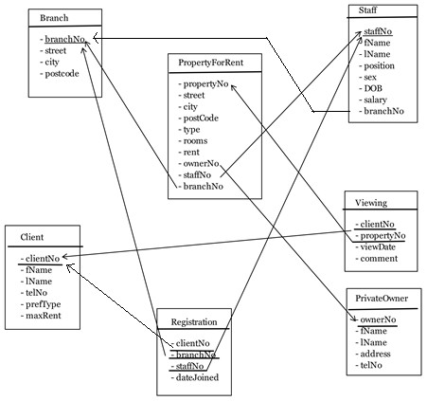
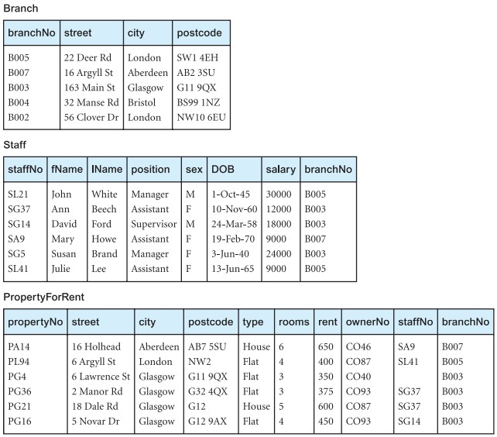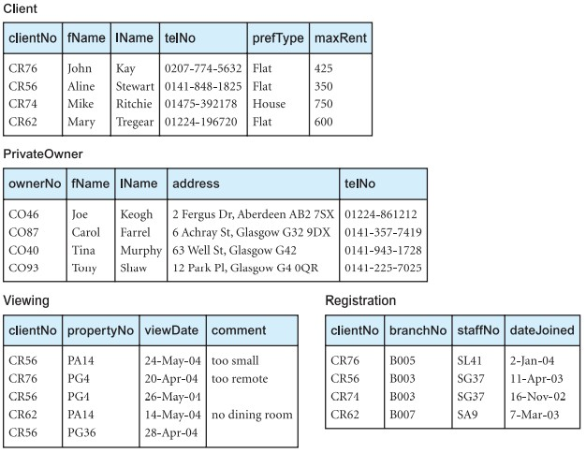

Question 2__ ________ Logical Constraints ___________ [2 x 5 = 10 marks]
For the database state and schema given to you please specify whether the following operations will be accepted or rejected. If they are rejected which constraint is being violated in that case. Note: please ignore syntax error if any.
- INSERT INTO Branch VALUES ('B005', '28 Link road', 'Lahore', 'V2S18');

ANSWER:

This command is accepted and data is entered in the Branch Table

- INSERT INTO Client VALUES (NULL, 'Hira', 'Faisal', '0337 2414981', 'Flat', 243);

ANSWER:

Rejected Null constraint is being violated because clientNo is primary key it cannot be null

- DELETE FROM Staff WHERE StaffNo = 'SG37';

ANSWER:

- UPDATE Staff SET BranchNo = 'B003' WHERE StaffNo = 'SL21';
- UPDATE Staff SET Salary = 'fifty thousand' WHERE StaffNo = 'SA9';

Question 3 DDL _[4 x 5 = 20 marks]
Write SQL statements satisfying the following requirements.
- Add a new table name vehicle with the following attributes: StaffNo is foreign key from table Staff
RegNo(pk) | Model | Year | Color | StaffNo(FK)
Integer | String  Size up to 15 | Fixed String 4 Digits | String  Size up to 15 | String  Size upto 5
- Add new column “staffNo” in Viewing after PropertyNo.
- The new column In viewing is foreign key coming from Staff. Write appropriatequery to create this relationship.
- On viewing we want to get detailed review from client. Change the data type ofcomment to varchar(150). Also change the name of comment to Review.

Question 4___ __ _DML _ [(3+2) x 7 = 35 marks]
Write SQL statements satisfying the following requirements. Also write RA expression as well.
- Retrieve the birthdate and Salary of Staff member 'John White'.
- Show street, city, rent and rooms for flats in London from PropertyForRent with 4 ormore bedrooms. Display the records in Descending order of their rent.
- In which cities we have flats available for rent in the price range of 300-450. Do notrepeat city name. The ‘city’ column name should be renamed as Locations in result.
- Show details of managers who have a salary between 9000 and 18000. (Use betweenonly)
- Show all private owners whose first name ends with ‘L’ and Last name has ‘R’ at third position.
- Show name, gender, salaries of supervisors along with the address of their branch.
- Show the names of private owners whose properties in Glasgow were viewed byclients looking for a flat but no comment was left.

